**ADK PYTHON PRACTICAL ROLL NO.05**

**EXPERIMENT NO – 1 (C)**

**C] Write a program to generate the Fibonacci series.**

**CODE:**

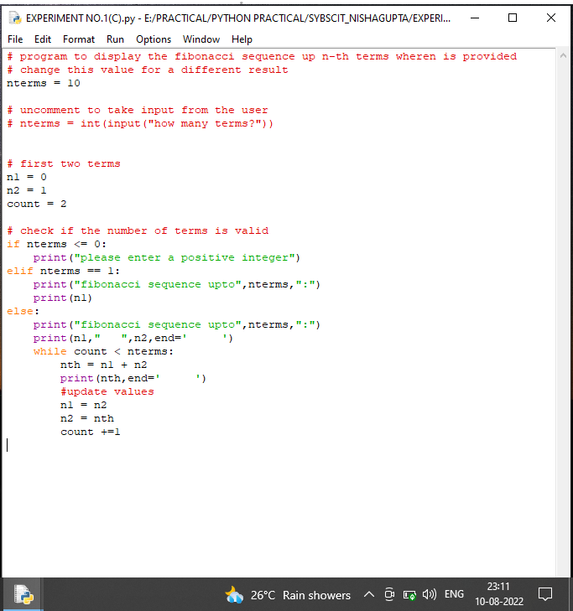

**OUTPUT:**

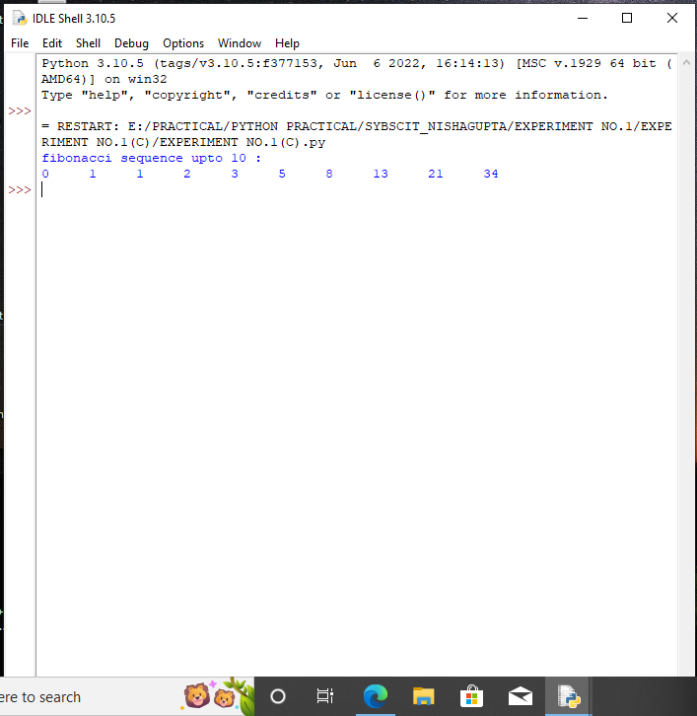

**CONCLUSION: successful program.**